**Use Case Document**

User/Actor –

* Manager, Ford Cars Dealership
* Customer
* Salesman

**Require:-**

* In this Dealership of Ford Cars having 3 cars model of Ford i.e., Mustang, Fiesta & Ecosports.
* Manager wants the list of monthly sales of by specifying any model by giving output.
* Manager wants know its profit per car by the help of Cost Price & Sell Price.
* Manager wants to know the name of responsible salesman of certain model of car.
* Manager wants know engine type of available Car model.
* Manager wants to number of cars available in stock.
* Manager wants to the quantity of defective Car.
* Manager also know each car steering side.
* Customer wants to sell & buy the car .
* Feedback is written by customer.
* Salesman wants to update the information about car price.
* Salesman can access the customer feedback experience for improvement.
* Salesman wants to advertise the occasional offer.
* Salesman generates the bill after giving the service.
* Salesman wants the list of contact of past customer.
* Salesman reports complaint about defected cars to manufacturers.

**Use Case Diagram For Car Dealership**

BUY

SELL

FEEDBACK

LIST OF PAST CUSTOMER

UPDATE COST OF CARS

GENERATE BILL

REPORT COMPLAINT TO MANUFACTURER ABOUT DEFECTED CARS

ADVERTISE ABOUT OSCASSIONAL

GET LIST OF MODEL WISE FULL REPORT OF MONTHLY SALES, REPONSIBLE SALESMAN, ENGINE TYPE, PROFIT PER CAR, AVAILABLE QUANTITY & STEERING SIDE

Classes/Interface Required For Program:-

* Class Ford (For manager)
* Interface Inventory (For manager)
* Class Mustang(For Manager)
* Class Ecosports(For Manager)
* Class Fiego(For Manager)
* Class Customer(For customer)
* Class Salesman(For salesman)

**CLASS DIAGRAM**

|  |
| --- |
| Class Salesman |
| - void getCustomerList()  - String complaint()  -String generatebill()  - costupdate()  -String advertise() |

|  |
| --- |
| Class Customer |
| -void buy() |
| -void sell() |
| -void feedback() |

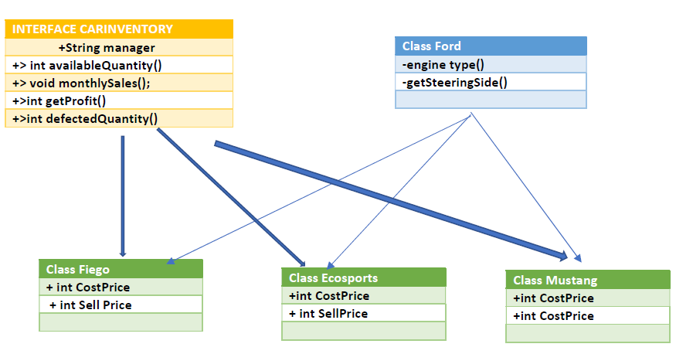

**Output with choosing salesman with customerlist set name&phone number**

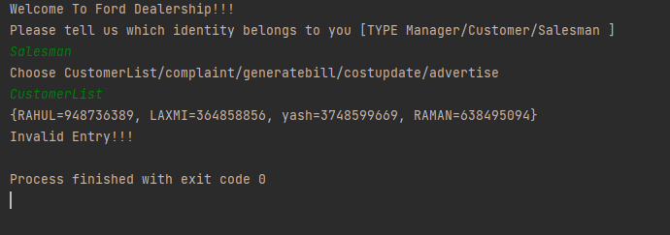

Choose customer with feedback 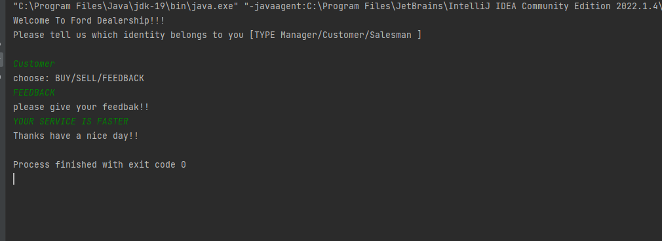

CHOOSE WITH MANAGER AS WELL AS CAR MODEL STATUS 